Andrew Davis & Caleb Harrison

Wireshark HTTP Experiment

Questions

* 1. The browser is running 1.1. The server is running 1.0.
  2. en-US, en
  3. Our Computer: 192.168.97.158 .edu Computer: 128.119.245.12
  4. Status Code: 200 OK
  5. 12:17 GMT July 19th, 2012
  6. 128 bytes
  7. The “Frame” header is not shown in the packet-content window.
  8. No.
  9. Yes. It shows the “Line-based text data”
  10. Yes
  11. 304 Not Modified
  12. One, packet #9
  13. Packet #9
  14. 200 OK
  15. 9
  16. Four, including favicon.ico
  17. Serially
  18. 401 UNAUTHORIZED
  19. Authorization - Credentials

Wireshark DNS Experiment

Questions

* + 1. 121.254.171.27
    2. ns1.garr.net | ns2.garr.net | dns1.iue.it | dns2.iue.it
    3. 98.139.241.94
    4. TCP
    5. 53 for both
    6. 12.22.58.30
    7. Standard Query | No Answers
    8. 1 Answer
    9. Yes
    10. Yes.
    11. 53
    12. 8.8.8.8, yes
    13. Standard, no
    14. 1, www.mit.edu : type a class IN addr 18.9.22.169

15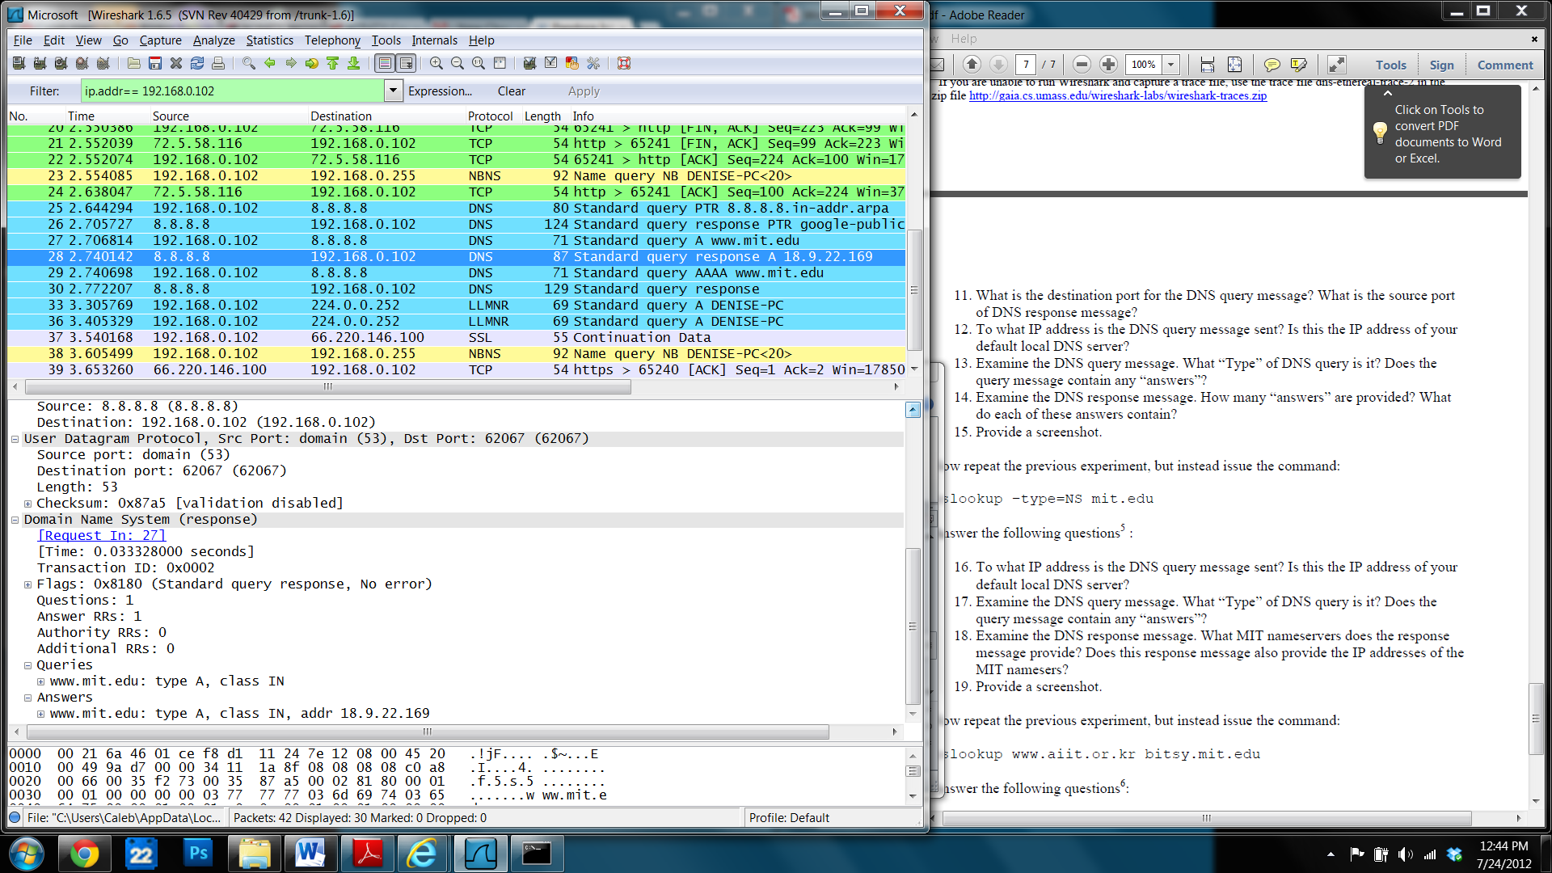

16 8.8.8.8 yes

17. standard ptr, no

18. bitsy.mit.edu, strawb.mit.edu, w20ns.mit.edu, no

19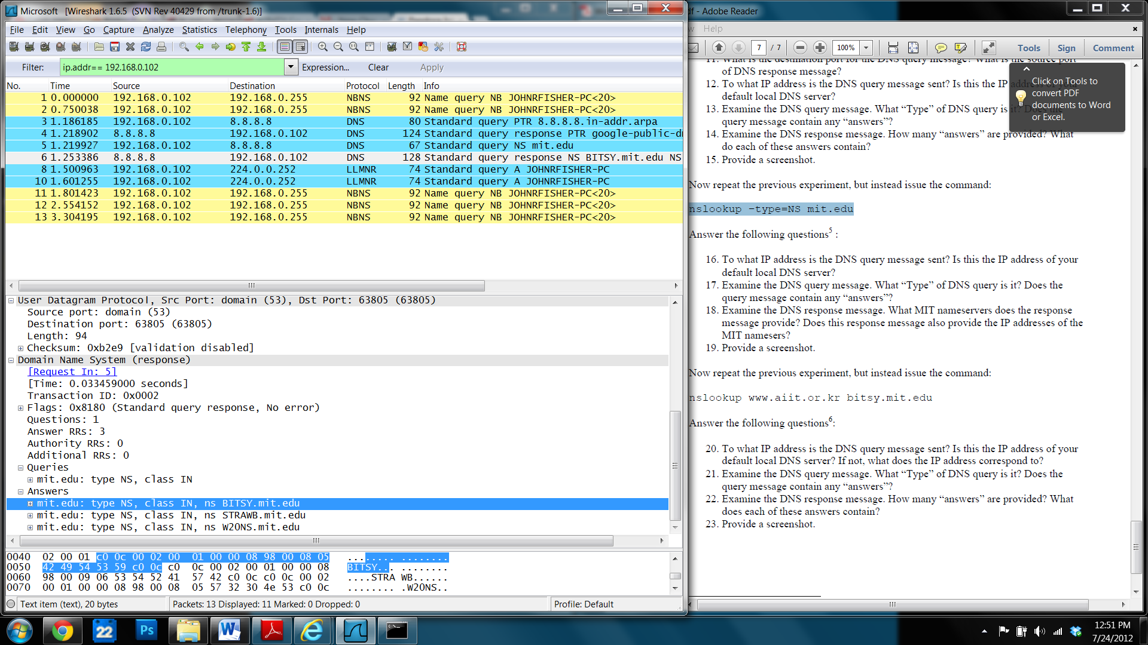

1. 18.72.0.3, no, this is the DNS server bitsy.mit.edu
2. Standard query a, no
3. 1, web site name, type, class, and ip address

